Operations on Singly Linked List
There are various operations which can be performed on singly linked list. A list of all such operations is given below.

Node Creation
- struct node
- {
- int data;
- struct node *next;
- };
- struct node *head, *ptr;
- ptr = (struct node *)malloc(sizeof(struct node *));

Insertion
The insertion into a singly linked list can be performed at different positions. Based on the position of the new node being inserted, the insertion is categorized into the following categories.
SN | Operation | Description
1 | Insertion at beginning | It involves inserting any element at the front of the list. We just need to a few link adjustments to make the new node as the head of the list.
2 | Insertion at end of the list | It involves insertion at the last of the linked list. The new node can be inserted as the only node in the list or it can be inserted as the last one. Different logics are implemented in each scenario.
3 | Insertion after specified node | It involves insertion after the specified node of the linked list. We need to skip the desired number of nodes in order to reach the node after which the new node will be inserted. .

Deletion and Traversing
The Deletion of a node from a singly linked list can be performed at different positions. Based on the position of the node being deleted, the operation is categorized into the following categories.
SN | Operation | Description
1 | Deletion at beginning | It involves deletion of a node from the beginning of the list. This is the simplest operation among all. It just need a few adjustments in the node pointers.
2 | Deletion at the end of the list | It involves deleting the last node of the list. The list can either be empty or full. Different logic is implemented for the different scenarios.
3 | Deletion after specified node | It involves deleting the node after the specified node in the list. we need to skip the desired number of nodes to reach the node after which the node will be deleted. This requires traversing through the list.
4 | Traversing | In traversing, we simply visit each node of the list at least once in order to perform some specific operation on it, for example, printing data part of each node present in the list.
5 | Searching | In searching, we match each element of the list with the given element. If the element is found on any of the location then location of that element is returned otherwise null is returned. .

Insertion in singly linked list at beginning
Inserting a new element into a singly linked list at beginning is quite simple. We just need to make a few adjustments in the node links. There are the following steps which need to be followed in order to inser a new node in the list at beginning.
- Allocate the space for the new node and store data into the data part of the node. This will be done by the following statements.
ptr = (struct node *) malloc(sizeof(struct node *));
ptr → data = item
- Make the link part of the new node pointing to the existing first node of the list. This will be done by using the following statement.
ptr->next = head;
- At the last, we need to make the new node as the first node of the list this will be done by using the following statement.
head = ptr;

Algorithm
- Step 1: IF PTR = NULL
Write OVERFLOW
Go to Step 7
[END OF IF]
- Step 2: SET NEW_NODE = PTR
- Step 3: SET PTR = PTR → NEXT
- Step 4: SET NEW_NODE → DATA = VAL
- Step 5: SET NEW_NODE → NEXT = HEAD
- Step 6: SET HEAD = NEW_NODE
- Step 7: EXIT
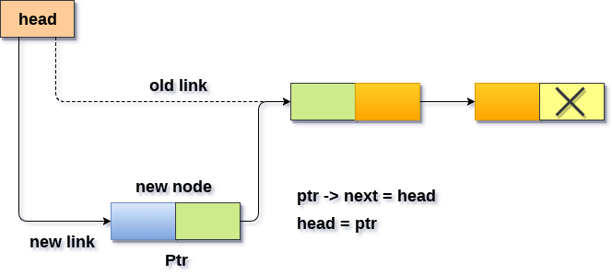

Insertion in singly linked list at the end
In order to insert a node at the last, there are two following scenarios which need to be mentioned.
- The node is being added to an empty list
- The node is being added to the end of the linked list

in the first case,
- The condition (head == NULL) gets satisfied. Hence, we just need to allocate the space for the node by using malloc statement in C. Data and the link part of the node are set up by using the following statements.
ptr->data = item;
ptr -> next = NULL;
- Since, ptr is the only node that will be inserted in the list hence, we need to make this node pointed by the head pointer of the list. This will be done by using the following Statements.
Head = ptr

In the second case,
- The condition Head = NULL would fail, since Head is not null. Now, we need to declare a temporary pointer temp in order to traverse through the list. temp is made to point the first node of the list.
Temp = head
- Then, traverse through the entire linked list using the statements:
while (temp→ next != NULL)
temp = temp → next;
- At the end of the loop, the temp will be pointing to the last node of the list. Now, allocate the space for the new node, and assign the item to its data part. Since, the new node is going to be the last node of the list hence, the next part of this node needs to be pointing to the null. We need to make the next part of the temp node (which is currently the last node of the list) point to the new node (ptr) .
temp = head;
while (temp -> next != NULL)
{
temp = temp -> next;
}
temp->next = ptr;
ptr->next = NULL;

Algorithm
- Step 1: IF PTR = NULL Write OVERFLOW
Go to Step 1
[END OF IF]
- Step 2: SET NEW_NODE = PTR
- Step 3: SET PTR = PTR - > NEXT
- Step 4: SET NEW_NODE - > DATA = VAL
- Step 5: SET NEW_NODE - > NEXT = NULL
- Step 6: SET PTR = HEAD
- Step 7: Repeat Step 8 while PTR - > NEXT != NULL
- Step 8: SET PTR = PTR - > NEXT
[END OF LOOP]
- Step 9: SET PTR - > NEXT = NEW_NODE
- Step 10: EXIT
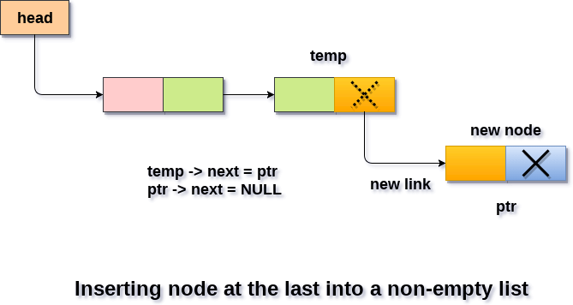

Insertion in singly linked list after specified Node
- In order to insert an element after the specified number of nodes into the linked list, we need to skip the desired number of elements in the list to move the pointer at the position after which the node will be inserted. This will be done by using the following statements.
Temp=head;
for(i=0;i<loc;i++)
{
temp = temp->next;
if(temp == NULL)
{
return;
}

}
- Allocate the space for the new node and add the item to the data part of it. This will be done by using the following statements.
ptr = (struct node *) malloc (sizeof(struct node));
ptr->data = item;
- Now, we just need to make a few more link adjustments and our node at will be inserted at the specified position. Since, at the end of the loop, the loop pointer temp would be pointing to the node after which the new node will be inserted. Therefore, the next part of the new node ptr must contain the address of the next part of the temp (since, ptr will be in between temp and the next of the temp). This will be done by using the following statements.
ptr→ next = temp → next
now, we just need to make the next part of the temp, point to the new node ptr. This will insert the new node ptr, at the specified position.
temp ->next = ptr;

Algorithm
- STEP 1: IF PTR = NULL
WRITE OVERFLOW
GOTO STEP 12
END OF IF
- STEP 2: SET NEW_NODE = PTR
- STEP 3: NEW_NODE → DATA = VAL
- STEP 4: SET TEMP = HEAD
- STEP 5: SET I = 0
- STEP 6: REPEAT STEP 5 AND 6 UNTIL I
- STEP 7: TEMP = TEMP → NEXT
- STEP 8: IF TEMP = NULL
WRITE "DESIRED NODE NOT PRESENT"
GOTO STEP 12
END OF IF
END OF LOOP
- STEP 9: PTR → NEXT = TEMP → NEXT
- STEP 10: TEMP → NEXT = PTR
- STEP 11: SET PTR = NEW_NODE
- STEP 12: EXIT
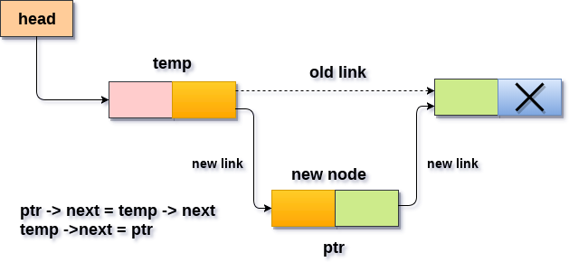

Deletion in singly linked list at beginning
Deleting a node from the beginning of the list is the simplest operation of all. It just need a few adjustments in the node pointers. Since the first node of the list is to be deleted, therefore, we just need to make the head, point to the next of the head. This will be done by using the following statements.
ptr = head;
head = ptr->next;
Now, free the pointer ptr which was pointing to the head node of the list. This will be done by using the following statement.
free(ptr)

Algorithm
- Step 1: IF HEAD = NULL
Write UNDERFLOW
Go to Step 5
[END OF IF]
- Step 2: SET PTR = HEAD
- Step 3: SET HEAD = HEAD -> NEXT
- Step 4: FREE PTR
- Step 5: EXIT
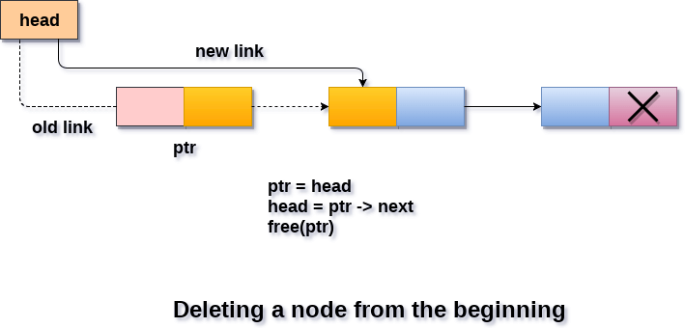

Deletion in singly linked list at the end
There are two scenarios in which, a node is deleted from the end of the linked list.
- There is only one node in the list and that needs to be deleted.
- There are more than one node in the list and the last node of the list will be deleted.

In the first scenario,
the condition head → next = NULL will survive and therefore, the only node head of the list will be assigned to null. This will be done by using the following statements.
ptr = head
head = NULL
free(ptr)

In the second scenario,
The condition head → next = NULL would fail and therefore, we have to traverse the node in order to reach the last node of the list.
For this purpose, just declare a temporary pointer temp and assign it to head of the list. We also need to keep track of the second last node of the list. For this purpose, two pointers ptr and ptr1 will be used where ptr will point to the last node and ptr1 will point to the second last node of the list.
ptr = head;
while(ptr->next != NULL)
{
ptr1 = ptr;
ptr = ptr ->next;
}
Now, we just need to make the pointer ptr1 point to the NULL and the last node of the list that is pointed by ptr will become free. It will be done by using the following statements.
ptr1->next = NULL;
free(ptr);

Algorithm
- Step 1: IF HEAD = NULL
Write UNDERFLOW
Go to Step 8
[END OF IF]
- Step 2: SET PTR = HEAD
- Step 3: Repeat Steps 4 and 5 while PTR -> NEXT!= NULL
- Step 4: SET PREPTR = PTR
- Step 5: SET PTR = PTR -> NEXT
[END OF LOOP]
- Step 6: SET PREPTR -> NEXT = NULL
- Step 7: FREE PTR
- Step 8: EXIT
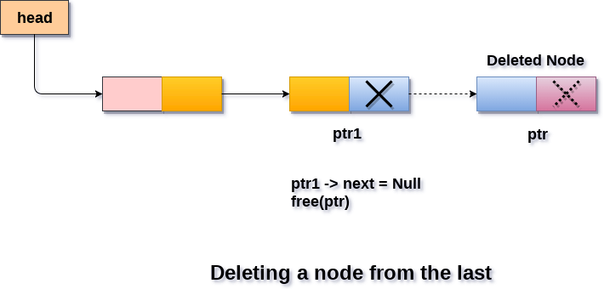

Deletion in singly linked list after the specified node :
In order to delete the node, which is present after the specified node, we need to skip the desired number of nodes to reach the node after which the node will be deleted. We need to keep track of the two nodes. The one which is to be deleted the other one if the node which is present before that node. For this purpose, two pointers are used: ptr and ptr1.
Use the following statements to do so.
ptr=head;
for(i=0;i<loc;i++)
{
ptr1 = ptr;
ptr = ptr->next;

if(ptr == NULL)
{
printf("\nThere are less than %d elements in the list..",loc);
return;
}
}
Now, our task is almost done, we just need to make a few pointer adjustments. Make the next of ptr1 (points to the specified node) point to the next of ptr (the node which is to be deleted).
This will be done by using the following statements.

ptr1 ->next = ptr ->next;
free(ptr);

Algorithm
- STEP 1: IF HEAD = NULL
WRITE UNDERFLOW
GOTO STEP 10
END OF IF
- STEP 2: SET TEMP = HEAD
- STEP 3: SET I = 0
- STEP 4: REPEAT STEP 5 TO 8 UNTIL I
- STEP 5: TEMP1 = TEMP
- STEP 6: TEMP = TEMP → NEXT
- STEP 7: IF TEMP = NULL
WRITE "DESIRED NODE NOT PRESENT"
GOTO STEP 12
END OF IF
- STEP 8: I = I+1
END OF LOOP
- STEP 9: TEMP1 → NEXT = TEMP → NEXT
- STEP 10: FREE TEMP
- STEP 11: EXIT
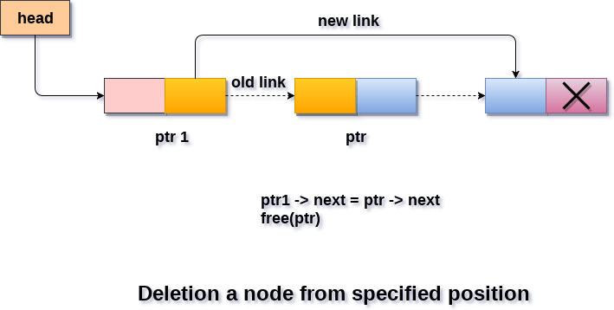

Traversing in singly linked list
Traversing is the most common operation that is performed in almost every scenario of singly linked list. Traversing means visiting each node of the list once in order to perform some operation on that. This will be done by using the following statements.
ptr = head;
while (ptr!=NULL)
{
ptr = ptr -> next;
}

Algorithm
- STEP 1: SET PTR = HEAD
- STEP 2: IF PTR = NULL
WRITE "EMPTY LIST"
GOTO STEP 7
END OF IF
- STEP 4: REPEAT STEP 5 AND 6 UNTIL PTR != NULL
- STEP 5: PRINT PTR→ DATA
- STEP 6: PTR = PTR → NEXT
[END OF LOOP]
- STEP 7: EXIT

Searching in singly linked list
Searching is performed in order to find the location of a particular element in the list. Searching any element in the list needs traversing through the list and make the comparison of every element of the list with the specified element. If the element is matched with any of the list element then the location of the element is returned from the function.

Algorithm
- Step 1: SET PTR = HEAD
- Step 2: Set I = 0
- STEP 3: IF PTR = NULL
WRITE "EMPTY LIST"
GOTO STEP 8
END OF IF
- STEP 4: REPEAT STEP 5 TO 7 UNTIL PTR != NULL
- STEP 5: if ptr → data = item
write i+1
End of IF
- STEP 6: I = I + 1
- STEP 7: PTR = PTR → NEXT
[END OF LOOP]
- STEP 8: EXIT

Doubly linked list
Doubly linked list is a complex type of linked list in which a node contains a pointer to the previous as well as the next node in the sequence. Therefore, in a doubly linked list, a node consists of three parts: node data, pointer to the next node in sequence (next pointer) , pointer to the previous node (previous pointer). A sample node in a doubly linked list is shown in the figure.
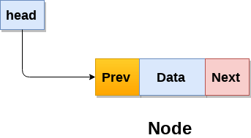
A doubly linked list containing three nodes having numbers from 1 to 3 in their data part, is shown in the following image.
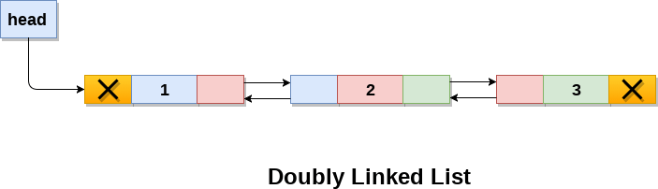
In C, structure of a node in doubly linked list can be given as :
struct node
{
struct node *prev;
int data;
struct node *next;
}
The prev part of the first node and the next part of the last node will always contain null indicating end in each direction.

Operations on doubly linked list
Node Creation
struct node
{
struct node *prev;
int data;
struct node *next;
};
struct node *head;
All the remaining operations regarding doubly linked list are described in the following table.
SN | Operation | Description
1 | Insertion at beginning | Adding the node into the linked list at beginning.
2 | Insertion at end | Adding the node into the linked list to the end.
3 | Insertion after specified node | Adding the node into the linked list after the specified node.
4 | Deletion at beginning | Removing the node from beginning of the list
5 | Deletion at the end | Removing the node from end of the list.
6 | Deletion of the node having given data | Removing the node which is present just after the node containing the given data.
7 | Searching | Comparing each node data with the item to be searched and return the location of the item in the list if the item found else return null.
8 | Traversing | Visiting each node of the list at least once in order to perform some specific operation like searching, sorting, display, etc.

Insertion in doubly linked list at beginning
As in doubly linked list, each node of the list contain double pointers therefore we have to maintain more number of pointers in doubly linked list as compare to singly linked list.
There are two scenarios of inserting any element into doubly linked list. Either the list is empty or it contains at least one element. Perform the following steps to insert a node in doubly linked list at beginning.
- Allocate the space for the new node in the memory. This will be done by using the following statement.
ptr = (struct node *)malloc(sizeof(struct node));
- Check whether the list is empty or not. The list is empty if the condition head == NULL holds. In that case, the node will be inserted as the only node of the list and therefore the prev and the next pointer of the node will point to NULL and the head pointer will point to this node.
ptr->next = NULL;
ptr->prev=NULL;
ptr->data=item;
head=ptr;
- In the second scenario, the condition head == NULL become false and the node will be inserted in beginning. The next pointer of the node will point to the existing head pointer of the node. The prev pointer of the existing head will point to the new node being inserted.
- This will be done by using the following statements.
ptr->next = head;
head→prev=ptr;
Since, the node being inserted is the first node of the list and therefore it must contain NULL in its prev pointer. Hence assign null to its previous part and make the head point to this node.
ptr→prev =NULL
head = ptr

Algorithm :
- Step 1: IF ptr = NULL
Write OVERFLOW
Go to Step 9
[END OF IF]
- Step 2: SET NEW_NODE = ptr
- Step 3: SET ptr = ptr -> NEXT
- Step 4: SET NEW_NODE -> DATA = VAL
- Step 5: SET NEW_NODE -> PREV = NULL
- Step 6: SET NEW_NODE -> NEXT = START
- Step 7: SET head -> PREV = NEW_NODE
- Step 8: SET head = NEW_NODE
- Step 9: EXIT
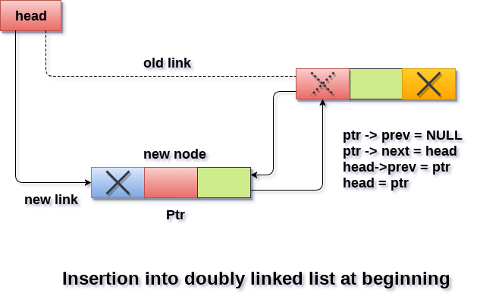

Insertion in doubly linked list at the end
In order to insert a node in doubly linked list at the end, we must make sure whether the list is empty or it contains any element. Use the following steps in order to insert the node in doubly linked list at the end.
- Allocate the memory for the new node. Make the pointer ptr point to the new node being inserted.
ptr = (struct node *) malloc(sizeof(struct node));
- Check whether the list is empty or not. The list is empty if the condition head == NULL holds. In that case, the node will be inserted as the only node of the list and therefore the prev and the next pointer of the node will point to NULL and the head pointer will point to this node.
ptr->next = NULL;
ptr->prev=NULL;
ptr->data=item;
head=ptr;
- In the second scenario, the condition head == NULL become false. The new node will be inserted as the last node of the list. For this purpose, we have to traverse the whole list in order to reach the last node of the list. Initialize the pointer temp to head and traverse the list by using this pointer.
Temp = head;
while (temp != NULL)
{
temp = temp → next;
}
the pointer temp point to the last node at the end of this while loop. Now, we just need to make a few pointer adjustments to insert the new node ptr to the list. First, make the next pointer of temp point to the new node being inserted i.e. ptr.
temp→next =ptr;
make the previous pointer of the node ptr point to the existing last node of the list i.e. temp.
ptr → prev = temp;
make the next pointer of the node ptr point to the null as it will be the new last node of the list.
ptr → next = NULL

Algorithm
- Step 1: IF PTR = NULL
Write OVERFLOW
Go to Step 11
[END OF IF]
- Step 2: SET NEW_NODE = PTR
- Step 3: SET PTR = PTR -> NEXT
- Step 4: SET NEW_NODE -> DATA = VAL
- Step 5: SET NEW_NODE -> NEXT = NULL
- Step 6: SET TEMP = START
- Step 7: Repeat Step 8 while TEMP -> NEXT != NULL
- Step 8: SET TEMP = TEMP -> NEXT
[END OF LOOP]
- Step 9: SET TEMP -> NEXT = NEW_NODE
- Step 10C: SET NEW_NODE -> PREV = TEMP
- Step 11: EXIT
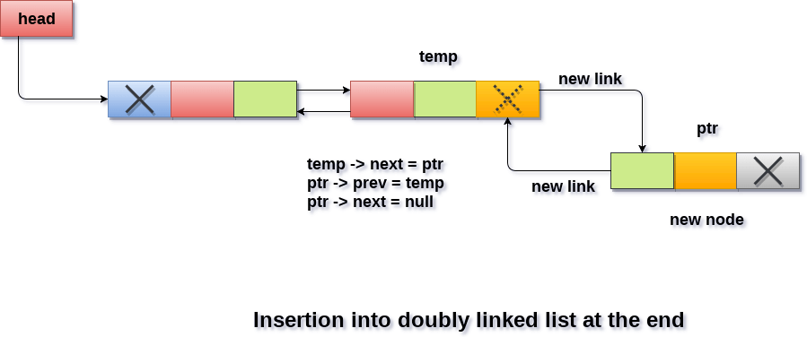

Insertion in doubly linked list after Specified node
In order to insert a node after the specified node in the list, we need to skip the required number of nodes in order to reach the mentioned node and then make the pointer adjustments as required.
Use the following steps for this purpose.
- Allocate the memory for the new node. Use the following statements for this.
ptr = (struct node *)malloc(sizeof(struct node));
- Traverse the list by using the pointer temp to skip the required number of nodes in order to reach the specified node.
temp=head;
for(i=0;i<loc;i++)
{
temp = temp->next;
if(temp == NULL) // the temp will be //null if the list doesn't last long //up to mentioned location
{
return;
}
}
- The temp would point to the specified node at the end of the for loop. The new node needs to be inserted after this node therefore we need to make a fer pointer adjustments here. Make the next pointer of ptr point to the next node of temp.
ptr → next = temp → next;
make the prev of the new node ptr point to temp.
ptr → prev = temp;
make the next pointer of temp point to the new node ptr.
temp → next = ptr;
make the previous pointer of the next node of temp point to the new node.
temp → next → prev = ptr;

Algorithm
- Step 1: IF PTR = NULL
Write OVERFLOW
Go to Step 15
[END OF IF]
- Step 2: SET NEW_NODE = PTR
- Step 3: SET PTR = PTR -> NEXT
- Step 4: SET NEW_NODE -> DATA = VAL
- Step 5: SET TEMP = START
- Step 6: SET I = 0
- Step 7: REPEAT 8 to 10 until I
- Step 8: SET TEMP = TEMP -> NEXT
- STEP 9: IF TEMP = NULL
- STEP 10: WRITE "LESS THAN DESIRED NO. OF ELEMENTS"
GOTO STEP 15
[END OF IF]
[END OF LOOP]
- Step 11: SET NEW_NODE -> NEXT = TEMP -> NEXT
- Step 12: SET NEW_NODE -> PREV = TEMP
- Step 13 : SET TEMP -> NEXT = NEW_NODE
- Step 14: SET TEMP -> NEXT -> PREV = NEW_NODE
- Step 15: EXIT
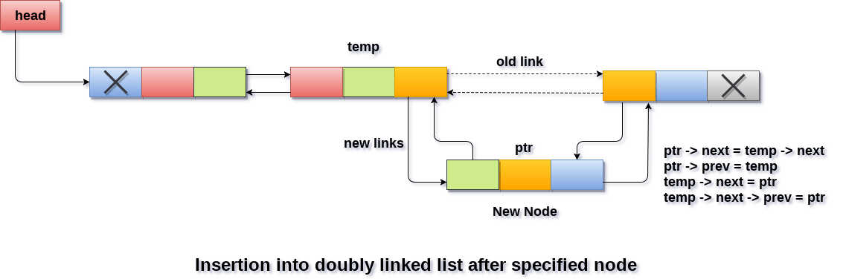

Deletion at beginning
Deletion in doubly linked list at the beginning is the simplest operation. We just need to copy the head pointer to pointer ptr and shift the head pointer to its next.
Ptr = head;
head = head → next;
now make the prev of this new head node point to NULL. This will be done by using the following statements.
head → prev = NULL
Now free the pointer ptr by using the free function.
free(ptr)

Algorithm
- STEP 1: IF HEAD = NULL
WRITE UNDERFLOW
GOTO STEP 6
- STEP 2: SET PTR = HEAD
- STEP 3: SET HEAD = HEAD → NEXT
- STEP 4: SET HEAD → PREV = NULL
- STEP 5: FREE PTR
- STEP 6: EXIT
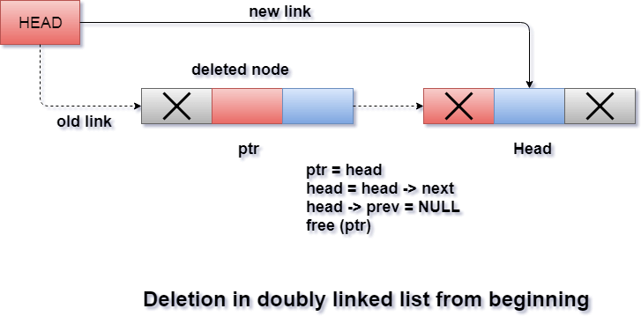

Deletion in doubly linked list at the end
Deletion of the last node in a doubly linked list needs traversing the list in order to reach the last node of the list and then make pointer adjustments at that position.
In order to delete the last node of the list, we need to follow the following steps.
- If the list is already empty then the condition head == NULL will become true and therefore the operation can not be carried on.
- If there is only one node in the list then the condition head → next == NULL become true. In this case, we just need to assign the head of the list to NULL and free head in order to completely delete the list.
- Otherwise, just traverse the list to reach the last node of the list. This will be done by using the following statements.
ptr = head;
if(ptr->next != NULL)
{
ptr = ptr -> next;
}
- The ptr would point to the last node of the ist at the end of the for loop. Just make the next pointer of the previous node of ptr to NULL.
ptr → prev → next = NULL
free the pointer as this the node which is to be deleted.
free(ptr)
- Step 1: IF HEAD = NULL
Write UNDERFLOW
Go to Step 7
[END OF IF]
- Step 2: SET TEMP = HEAD
- Step 3: REPEAT STEP 4 WHILE TEMP->NEXT != NULL
- Step 4: SET TEMP = TEMP->NEXT
[END OF LOOP]
- Step 5: SET TEMP ->PREV-> NEXT = NULL
- Step 6: FREE TEMP
- Step 7: EXIT

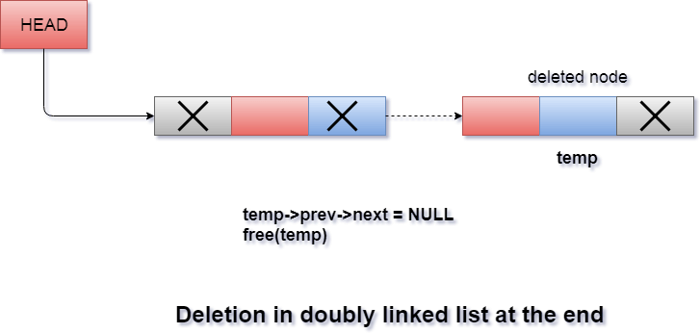

Deletion in doubly linked list after the specified node
In order to delete the node after the specified data, we need to perform the following steps.
- Copy the head pointer into a temporary pointer temp.
temp = head
- Traverse the list until we find the desired data value.
while(temp -> data != val)
temp = temp -> next;
- Check if this is the last node of the list. If it is so then we can't perform deletion.
if(temp -> next == NULL)
{
return;
}
- Check if the node which is to be deleted, is the last node of the list, if it so then we have to make the next pointer of this node point to null so that it can be the new last node of the list.
if(temp -> next -> next == NULL)
{
temp ->next = NULL;
}
- Otherwise, make the pointer ptr point to the node which is to be deleted. Make the next of temp point to the next of ptr. Make the previous of next node of ptr point to temp. free the ptr.
ptr = temp -> next;
temp -> next = ptr -> next;
ptr -> next -> prev = temp;
free(ptr);

Algorithm
- Step 1: IF HEAD = NULL
Write UNDERFLOW
Go to Step 9
[END OF IF]
- Step 2: SET TEMP = HEAD
- Step 3: Repeat Step 4 while TEMP -> DATA != ITEM
- Step 4: SET TEMP = TEMP -> NEXT
[END OF LOOP]
- Step 5: SET PTR = TEMP -> NEXT
- Step 6: SET TEMP -> NEXT = PTR -> NEXT
- Step 7: SET PTR -> NEXT -> PREV = TEMP
- Step 8: FREE PTR
- Step 9: EXIT
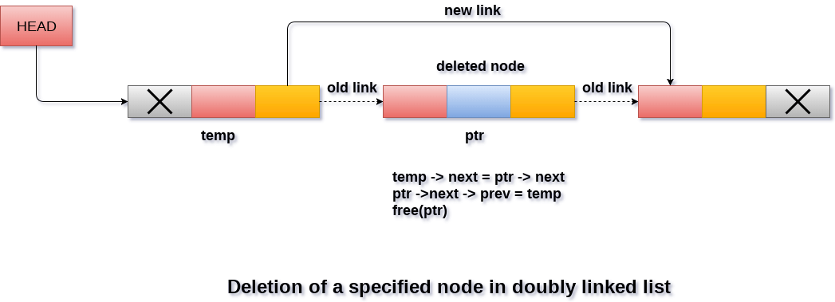

Searching for a specific node in Doubly Linked List
Traverse the list in order to search for a specific element in the list. Perform following operations in order to search a specific operation.
- Copy head pointer into a temporary pointer variable ptr.
ptr = head
- declare a local variable I and assign it to 0.
i=0
- Traverse the list until the pointer ptr becomes null. Keep shifting pointer to its next and increasing i by +1.
- Compare each element of the list with the item which is to be searched.
- If the item matched with any node value then the location of that value I will be returned from the function else NULL is returned.

Algorithm
- Step 1: IF HEAD == NULL
WRITE "UNDERFLOW"
GOTO STEP 8
[END OF IF]
- Step 2: Set PTR = HEAD
- Step 3: Set i = 0
- Step 4: Repeat step 5 to 7 while PTR != NULL
- Step 5: IF PTR → data = item
return i
[END OF IF]
- Step 6: i = i + 1
- Step 7: PTR = PTR → next
- Step 8: Exit

Traversing in doubly linked list
Traversing is the most common operation in case of each data structure. For this purpose, copy the head pointer in any of the temporary pointer ptr.
Ptr = head
then, traverse through the list by using while loop. Keep shifting value of pointer variable ptr until we find the last node. The last node contains null in its next part.
while(ptr != NULL)
{
printf("%d\n",ptr->data);
ptr=ptr->next;
}
Although, traversing means visiting each node of the list once to perform some specific operation. Here, we are printing the data associated with each node of the list.

Algorithm
- Step 1: IF HEAD == NULL
WRITE "UNDERFLOW"
GOTO STEP 6
[END OF IF]
- Step 2: Set PTR = HEAD
- Step 3: Repeat step 4 and 5 while PTR != NULL
- Step 4: Write PTR → data
- Step 5: PTR = PTR → next
- Step 6: Exit

Circular Singly Linked List
In a circular Singly linked list, the last node of the list contains a pointer to the first node of the list. We can have circular singly linked list as well as circular doubly linked list.
We traverse a circular singly linked list until we reach the same node where we started. The circular singly liked list has no beginning and no ending. There is no null value present in the next part of any of the nodes.
The following image shows a circular singly linked list.
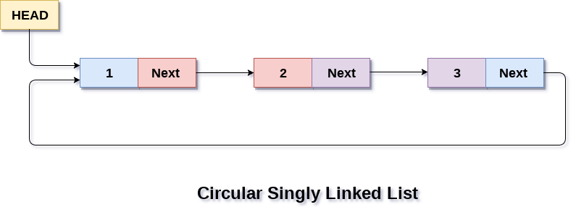
Circular linked list are mostly used in task maintenance in operating systems. There are many examples where circular linked list are being used in computer science including browser surfing where a record of pages visited in the past by the user, is maintained in the form of circular linked lists and can be accessed again on clicking the previous button.
ADVERTISEMENT

Memory Representation of circular linked list:
In the following image, memory representation of a circular linked list containing marks of a student in 4 subjects. However, the image shows a glimpse of how the circular list is being stored in the memory. The start or head of the list is pointing to the element with the index 1 and containing 13 marks in the data part and 4 in the next part. Which means that it is linked with the node that is being stored at 4th index of the list.
However, due to the fact that we are considering circular linked list in the memory therefore the last node of the list contains the address of the first node of the list.
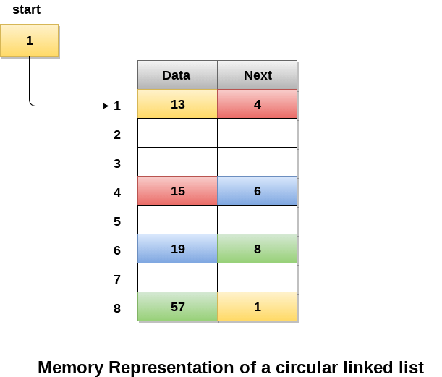
We can also have more than one number of linked list in the memory with the different start pointers pointing to the different start nodes in the list. The last node is identified by its next part which contains the address of the start node of the list. We must be able to identify the last node of any linked list so that we can find out the number of iterations which need to be performed while traversing the list.

Operations on Circular Singly linked list:

Insertion
SN | Operation | Description
1 | Insertion at beginning | Adding a node into circular singly linked list at the beginning.
2 | Insertion at the end | Adding a node into circular singly linked list at the end.

Deletion & Traversing
SN | Operation | Description
1 | Deletion at beginning | Removing the node from circular singly linked list at the beginning.
2 | Deletion at the end | Removing the node from circular singly linked list at the end.
3 | Searching | Compare each element of the node with the given item and return the location at which the item is present in the list otherwise return null.
4 | Traversing | Visiting each element of the list at least once in order to perform some specific operation.

Insertion into circular singly linked list at beginning
There are two scenario in which a node can be inserted in circular singly linked list at beginning. Either the node will be inserted in an empty list or the node is to be inserted in an already filled list.
Firstly, allocate the memory space for the new node by using the malloc method of C language.
struct node *ptr = (struct node *)malloc(sizeof(struct node));
In the first scenario, the condition head == NULL will be true. Since, the list in which, we are inserting the node is a circular singly linked list, therefore the only node of the list (which is just inserted into the list) will point to itself only. We also need to make the head pointer point to this node. This will be done by using the following statements.
if(head == NULL)
{
head = ptr;
ptr -> next = head;
}
In the second scenario, the condition head == NULL will become false which means that the list contains at least one node. In this case, we need to traverse the list in order to reach the last node of the list. This will be done by using the following statement.
temp = head;
while(temp->next != head)
temp = temp->next;
At the end of the loop, the pointer temp would point to the last node of the list. Since, in a circular singly linked list, the last node of the list contains a pointer to the first node of the list. Therefore, we need to make the next pointer of the last node point to the head node of the list and the new node which is being inserted into the list will be the new head node of the list therefore the next pointer of temp will point to the new node ptr.
This will be done by using the following statements.
temp -> next = ptr;
the next pointer of temp will point to the existing head node of the list.
ptr->next = head;
Now, make the new node ptr, the new head node of the circular singly linked list.
head = ptr;
in this way, the node ptr has been inserted into the circular singly linked list at beginning.

Algorithm
- Step 1: IF PTR = NULL
Write OVERFLOW
Go to Step 11
[END OF IF]
- Step 2: SET NEW_NODE = PTR
- Step 3: SET PTR = PTR -> NEXT
- Step 4: SET NEW_NODE -> DATA = VAL
- Step 5: SET TEMP = HEAD
- Step 6: Repeat Step 8 while TEMP -> NEXT != HEAD
- Step 7: SET TEMP = TEMP -> NEXT
[END OF LOOP]
- Step 8: SET NEW_NODE -> NEXT = HEAD
- Step 9: SET TEMP → NEXT = NEW_NODE
- Step 10: SET HEAD = NEW_NODE
- Step 11: EXIT
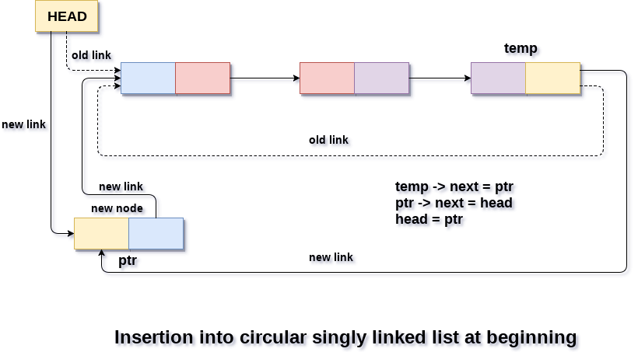

Insertion into circular singly linked list at the end
There are two scenario in which a node can be inserted in circular singly linked list at beginning. Either the node will be inserted in an empty list or the node is to be inserted in an already filled list.
• Firstly, allocate the memory space for the new node by using the malloc method of C language.
struct node *ptr = (struct node *)malloc(sizeof(struct node));
In the first scenario, the condition head == NULL will be true. Since, the list in which, we are inserting the node is a circular singly linked list, therefore the only node of the list (which is just inserted into the list) will point to itself only. We also need to make the head pointer point to this node. This will be done by using the following statements.
if(head == NULL)
{
head = ptr;
ptr -> next = head;
}
In the second scenario, the condition head == NULL will become false which means that the list contains at least one node. In this case, we need to traverse the list in order to reach the last node of the list. This will be done by using the following statement.
temp = head;
while(temp->next != head)
temp = temp->next;
At the end of the loop, the pointer temp would point to the last node of the list. Since, the new node which is being inserted into the list will be the new last node of the list. Therefore the existing last node i.e. temp must point to the new node ptr. This is done by using the following statement.
temp -> next = ptr;
The new last node of the list i.e. ptr will point to the head node of the list.
ptr -> next = head;
In this way, a new node will be inserted in a circular singly linked list at the beginning.

Algorithm
- Step 1: IF PTR = NULL
Write OVERFLOW
Go to Step 1
[END OF IF]
- Step 2: SET NEW_NODE = PTR
- Step 3: SET PTR = PTR -> NEXT
- Step 4: SET NEW_NODE -> DATA = VAL
- Step 5: SET NEW_NODE -> NEXT = HEAD
- Step 6: SET TEMP = HEAD
- Step 7: Repeat Step 8 while TEMP -> NEXT != HEAD
- Step 8: SET TEMP = TEMP -> NEXT
[END OF LOOP]
- Step 9: SET TEMP -> NEXT = NEW_NODE
- Step 10: EXIT
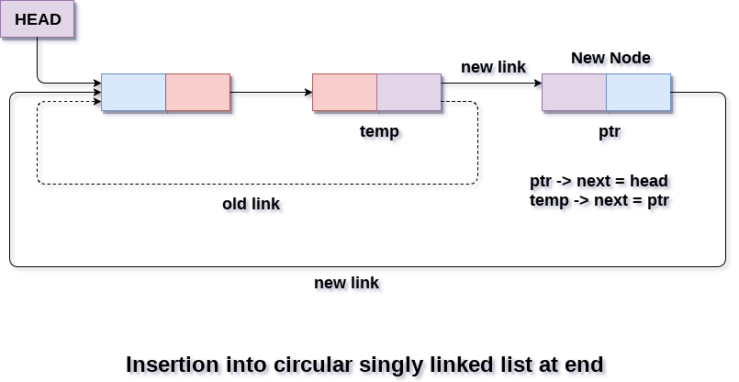

Deletion in circular singly linked list at beginning
In order to delete a node in circular singly linked list, we need to make a few pointer adjustments.
There are three scenarios of deleting a node from circular singly linked list at beginning.

Scenario 1: (The list is Empty)
If the list is empty then the condition head == NULL will become true, in this case, we just need to print underflow on the screen and make exit.
if(head == NULL)
{
printf("\nUNDERFLOW");
return;
}

Scenario 2: (The list contains single node)
If the list contains single node then, the condition head → next == head will become true. In this case, we need to delete the entire list and make the head pointer free. This will be done by using the following statements.
if(head->next == head)
{
head = NULL;
free(head);
}

Scenario 3: (The list contains more than one node)
If the list contains more than one node then, in that case, we need to traverse the list by using the pointer ptr to reach the last node of the list. This will be done by using the following statements.
ptr = head;
while(ptr -> next != head)
ptr = ptr -> next;
At the end of the loop, the pointer ptr point to the last node of the list. Since, the last node of the list points to the head node of the list. Therefore this will be changed as now, the last node of the list will point to the next of the head node.
ptr->next = head->next;
Now, free the head pointer by using the free() method in C language.
free(head);
Make the node pointed by the next of the last node, the new head of the list.
head = ptr->next;
In this way, the node will be deleted from the circular singly linked list from the beginning.

Algorithm
- Step 1: IF HEAD = NULL
Write UNDERFLOW
Go to Step 8
[END OF IF]
- Step 2: SET PTR = HEAD
- Step 3: Repeat Step 4 while PTR → NEXT != HEAD
- Step 4: SET PTR = PTR → next
[END OF LOOP]
- Step 5: SET PTR → NEXT = HEAD → NEXT
- Step 6: FREE HEAD
- Step 7: SET HEAD = PTR → NEXT
- Step 8: EXIT
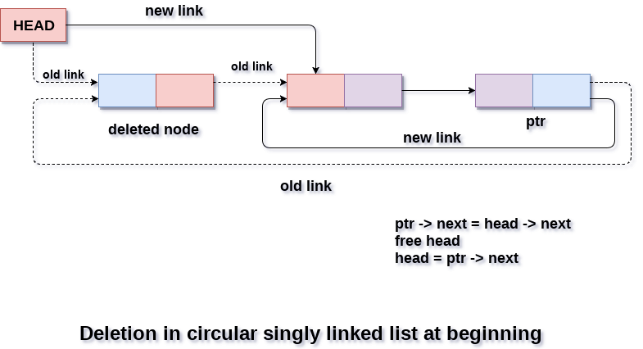

Deletion in Circular singly linked list at the end
There are three scenarios of deleting a node in circular singly linked list at the end.

Scenario 1 (the list is empty)
If the list is empty then the condition head == NULL will become true, in this case, we just need to print underflow on the screen and make exit.
if(head == NULL)
{
printf("\nUNDERFLOW");
return;
}

Scenario 2(the list contains single element)
If the list contains single node then, the condition head → next == head will become true. In this case, we need to delete the entire list and make the head pointer free. This will be done by using the following statements.
if(head->next == head)
{
head = NULL;
free(head);
}

Scenario 3(the list contains more than one element)
If the list contains more than one element, then in order to delete the last element, we need to reach the last node. We also need to keep track of the second last node of the list. For this purpose, the two pointers ptr and preptr are defined. The following sequence of code is used for this purpose.
ptr = head;
while(ptr ->next != head)
{
preptr=ptr;
ptr = ptr->next;
}
now, we need to make just one more pointer adjustment. We need to make the next pointer of preptr point to the next of ptr (i.e. head) and then make pointer ptr free.
preptr->next = ptr -> next;
free(ptr);

Algorithm
- Step 1: IF HEAD = NULL
Write UNDERFLOW
Go to Step 8
[END OF IF]
- Step 2: SET PTR = HEAD
- Step 3: Repeat Steps 4 and 5 while PTR -> NEXT != HEAD
- Step 4: SET PREPTR = PTR
- Step 5: SET PTR = PTR -> NEXT
[END OF LOOP]
- Step 6: SET PREPTR -> NEXT = HEAD
- Step 7: FREE PTR
- Step 8: EXIT
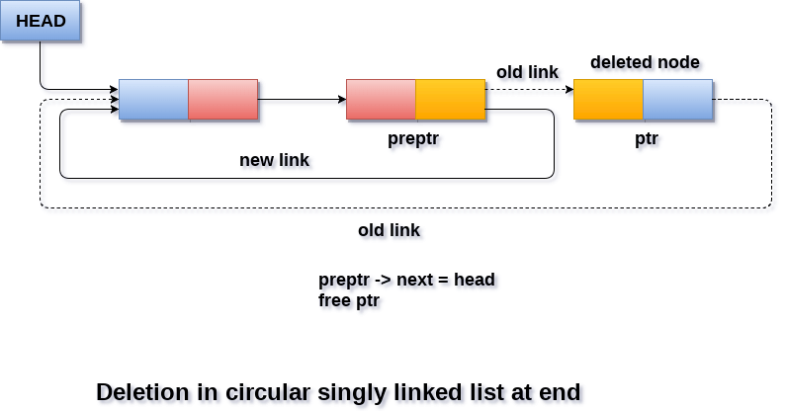

Searching in circular singly linked list
Searching in circular singly linked list needs traversing across the list. The item which is to be searched in the list is matched with each node data of the list once and if the match found then the location of that item is returned otherwise -1 is returned.
The algorithm and its implementation in C is given as follows.

Algorithm
- Step 1: SET PTR = HEAD
- Step 2: Set I = 0
- STEP 3: IF PTR = NULL
WRITE "EMPTY LIST"
GOTO STEP 8
END OF IF
- STEP 4: IF HEAD → DATA = ITEM
WRITE i+1 RETURN [END OF IF]
- STEP 5: REPEAT STEP 5 TO 7 UNTIL PTR->next != head
- STEP 6: if ptr → data = item
write i+1
RETURN
End of IF
- STEP 7: I = I + 1
- STEP 8: PTR = PTR → NEXT
[END OF LOOP]
- STEP 9: EXIT

Traversing in Circular Singly linked list
Traversing in circular singly linked list can be done through a loop. Initialize the temporary pointer variable temp to head pointer and run the while loop until the next pointer of temp becomes head. The algorithm and the c function implementing the algorithm is described as follows.

Algorithm
- STEP 1: SET PTR = HEAD
- STEP 2: IF PTR = NULL
WRITE "EMPTY LIST"
GOTO STEP 8
END OF IF
- STEP 4: REPEAT STEP 5 AND 6 UNTIL PTR → NEXT != HEAD
- STEP 5: PRINT PTR → DATA
- STEP 6: PTR = PTR → NEXT
[END OF LOOP]
- STEP 7: PRINT PTR→ DATA
- STEP 8: EXIT

